ABE 55700

September 2018

Group 1

Phase 1

Atherton

Chatterjee

McAnulty

O’Neill

### 

**Statement of Purpose** **3**

**Project Objectives** **3**

Understand the process of creating yogurt and alternative methods for creation 3

Create a recipe for yogurt and perform a mass balance on this recipe 3

Perform an energy balance on the recipe 3

Perform kitchen experiments to make a prototype of the yogurt 3

Communicate results of project 3

**Discussion: Yogurt Trends & Global Impact** **3**

History and Basics 3

Sustainable Processing 4

Global, Ethical, and Societal Issues 5

**Literature and Data Review** **5**

Yogurt Production Technology Review 5

Current Market State and Future Directions 7

**Recipe** **7**

Product Ingredients / Functionality 7

Product Recipe / Steps 7

**Process Review** **9**

**Management Plan** **10**

Tasks and Deadlines 10

Group Member Responsibilities 11

**Resources** **12**

### 

### Statement of Purpose

To develop an efficient, sustainable process for manufacturing a yogurt product that would prove to be successful in the current market.

### Project Objectives

#### Understand the process of creating yogurt and alternative methods for creation

* + Comprehend methods of dehydrating and rehydrating a food product
  + Recognize the physical and chemical changes performed during yogurt creation
  + Identify issues for product including pathogens, spoilage, and fermentation cultures
  + Be aware of the effects of processing on quality and functionality of product and identify methods to reduce waste and energy consumption

#### Create a recipe for yogurt and perform a mass balance on this recipe

* + Identify recipe including processing steps and ingredients
  + Perform component mass balance at each step and for the overall process
  + Identify materials needed to conduct experiments

#### Perform an energy balance on the recipe

* + Include thermal and physical properties in energy balance calculations
  + Record types of heat transfer mediums required

#### Perform kitchen experiments to make a prototype of the yogurt

* + Develop Plackett-Burman experimental design
  + Examine variables of the final product to determine success of product
  + Present preliminary results
  + Suggest future improvements

#### Communicate results of project

* + Create powerpoint presentation of process and results
  + Final literature review
  + Summarize process and results
  + Future improvements

### Discussion: Yogurt Trends & Global Impact

#### History and Basics

To cover the full scope of yogurt market trends, milk production must also be discussed. Approximately 20% of the world’s milk is produced in the United States. At an efficiency of 8.50 t/cow, the United States is the second most efficient milk producer. Great strides have been made towards the packaging and processing of milk products to increase yield production. Over the course of the early 2000s, manufacturing developments reduced the number of plants by 45% and increased the production yield by 4-5%. Continued developments in the milk industry increase the production of fermented dairy products such as yogurt (Chandan, 2006).

Yogurt is a fermented milk product and is thought to be discovered by primitive methods of storage in warm climates. With a host of lactic acid bacteria such as *Lactobacillus bulgaricus* and *Streptococcus thermophilus*, milk sours the at the appropriate growth temperatures which adds flavor and texture to the fermented product. There are 400 diverse products created by milk fermentation adding different flavors while conserving vital nutrients of milk. The fermentation of yogurt relates to process parameters such as moisture content and protein level. The majority of yogurt utilizes cow’s milk as a starting material and mixing with nonfat dry milk, milk protein concentrate, or condensed skim milk to produce a custard like consistency. There are multiple varieties of yogurt to investigate such as plain, fruit flavors, whipped, dried, and frozen (Chandan, 2006).

The popularity of yogurt soared based on consumer perceptions of health benefits. It is a significant source of protein and calcium and there is evidence it may lower the risk of diseases type II diabetes, obesity, and irritable bowel syndrome (“Yogurt”, 2018). Due to the possible health benefits and distinct flavor, the yogurt market reached a retail sales of $8.8 billion in 2017 (“United States”, 2018). Novel developments are being investigated to see possible market impacts.

#### Sustainable Processing

The World Wildlife Foundation claims that the greenhouse gas emissions created by cows and their manure are contributing to climate change while unsustainable dairy farming practices can lead to the loss of prairies, wetlands, and forests. Vast quantities of water are also used to keep cows productive and profitable; according to the Water Education Foundation, it takes 88 gallons to produce a cup of yogurt and up to 616 gallons of water to produce a 4-ounce hamburger.

Laureati et al. performed a social sciences study to assess consumer attitudes toward sustainable production and how those influence consumer preferences in yogurt. In general, consumers see “sustainability” as a positive ideal but do not necessarily adjust their buying behavior to align with their vision for a sustainable future. Some of this contradictory behavior is related to the inability of surveyed consumers to produce a consistent, informed definition of sustainability, which is a vast, interdisciplinary concept. Consumers with a more developed passion for sustainability had higher expectations for organic yogurt products. As a result, negative disconfirmation, when expectations for the product were higher than the assessment product characteristics after consumption, occurred only in consumers who were sustainability-minded or uncertain about sustainability. In order to maintain a customer base for those groups of consumers, organic products must meet or exceed expectations--an extra pressure that non-organic products do not have.

#### Global, Ethical, and Societal Issues

As yogurt is a dairy product, it is subject to the ethical dilemmas of dairy industry. According to an article written by Chas Newkey-Burden for *The Guardian* (2017), in order to produce the milk used in dairy products, female cows are artificially inseminated and then her calf is taken away from her in as little as 36 hours after birth. The milk produced by the cow for the calf is what is harvested for sale. The mother is typically stressed, wondering where her child is. Male calves are raised to be sold as veal while female calves are prepared to become dairy cows as well. Dairy cows typically live to be five years old, when their natural lifespan can be up to 25 years (Newkey-Burden, 2017).

In addition to the stress of the cycle of impregnation and milk production, Newkey-Burden reports, dairy cows are often injected with hormones and antibiotics to ensure that they produce more milk than they naturally would; naturally, a cow will produce 2 liters of milk for her offspring, but some farmers will give a cow enough hormones to cause her to carry 20 liters of milk, making her udders heavy and exhausting her body. Once she is no longer profitable, she is sold to become beef (Newkey-Burden, 2017).

These ethical issues have caused many people to adopt vegetarian or vegan diets, cutting out meat and dairy products. According to a Nielsen survey quoted by the Food Revolution Network, 39% of consumers in the United States are trying to incorporate more plant-based foods in their diets.

Being a dairy product, the yogurt market is affected by dietary restrictions, such as lactose-intolerance or allergies. Scrimshaw and Murray found that in North America, 79% of Native Americans, 71% of blacks, 51% of hispanics, and 21% of caucasians had lactose maldigestion, which is clearly evolutionarily linked. Consumers with an inability to process lactose may elect to purchase medicine to help them digest the sugar or to purchase products that they can easily consume.

### Literature and Data Review

#### Yogurt Production Technology Review

Traditionally, yogurt manufacturing includes warm milk being heat-treated above 85℃ and homogenized at 15-20 MPa. The main purpose of these processes is to reduce microbial load. Demonstrating the benefits of high-pressure homogenization (HPH), Serra et. al. worked with pressures up to 330 MPa to produce a yogurt product with higher gel strength and firmness and with less acid and syneresis. If syneresis is prevalent, the yogurt manufacturer may add a stabilizer at an extra cost. Processing milk below 30 degrees may allow for lipids in a solid state. All milk in this study was 30-40℃ to ensure liquid fats, and HPH proved to reduce fat globule size. In the design of a yogurt process, the manufacturer must weigh the pros and cons of milk processing in order to produce the desired results.

Following fermentation, yogurt is chilled to inhibit microbial activity and almost always kept at a refrigerated temperature for its entire shelf life. In order to produce a longer-lasting yogurt product with the same health benefits as the refrigerated liquid, the following US Patent Numbers describe products and processes for an instant yogurt: 1269769, 4289788, 4624853, 5145697. To make yogurt powder that does not kill the live cultures during dehydration, many commercial drying techniques are applicable, but spray drying is preferred. Not only do these yogurt products contain proteins and live cultures like traditional liquid yogurt, but they also must have a gelling system--normally with xanthan gum and locust bean gum. A challenge in developing a product intended for long shelf life is that various flavorings alter key stability parameters, such as pH. For example, strawberry, orange, and other fruit flavors often result in a pH below 6 whereas chocolate flavoring establishes an alkaline pH. From patent 5145697, the following table 1 gives an example of a chocolate-flavored dry yogurt product that is intended to be reconstituted in ⅔ cup milk (Cajigas, 1992).

*Table 1: Example Ingredient List for Chocolate-Flavored Dry Yogurt Product*

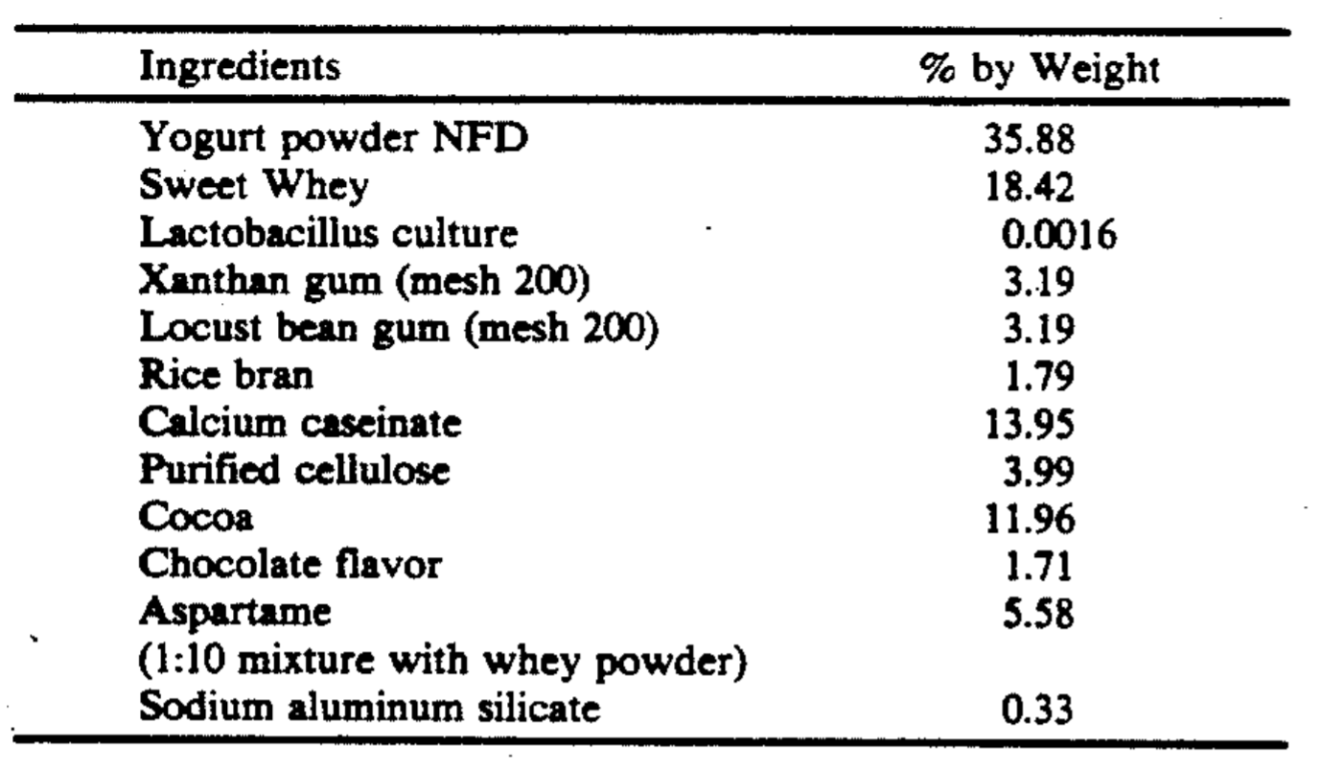

Because they compete with harmful pathogens, yogurts are known to be beneficial for gut health but can contain several probiotics that react with human digestive systems differently. For example, when four strains of *Bifidobacteria* were compared, *B. animalis* had the best survival rate through the human intestinal tract (Adolfsson et al., 2004). Chuayana et al. sampled major yogurt brands to isolate and cultivate the probiotics. The study did conclude that probiotics inhibit and/or kill pathogens. Additionally, probiotics in yogurt do outcompete periodontal pathogens without inhibiting beneficial bacteria; however, these results were shown *in vitro* often with the probiotic being inoculated first (Zhu, 2010). Some yogurt probiotics have shown a 2- or 3-log decrease during a 30-day refrigeration period (Allgeyer et al., 2010). In the design of a yogurt product, the manufacturer must evaluate which organisms are best to maximize human health and production efficiency.

#### Current Market State and Future Directions

According to the Mintel Group’s market research (2017), interest in spoonable yogurt decreased nearly 7% between 2015 and 2017 as an interest in convenient and portable yogurt products, such as yogurt beverages, has been an increasing trend and are expected to see a 58% growth over the next four years. Additionally, the market has been more concerned about the health benefits of yogurt, so about 30% of consumers seek out yogurt with low sugar content. Despite these concerns, the yogurt industry as a whole should continue to see strong growth and keep sales at around $9 billion per year for the next four years. Opportunities for the yogurt industry include new flavors and textures including thick Icelandic yogurt or creamy Australian yogurt. The ideal yogurt to consumers contains a lot of protein and probiotics but low sugars (Mintel, 2017).

Based upon the market research, the yogurt product would be most successful if it were portable, healthful, and had a new texture. As such, we believe that our ideal final product is dehydrated yogurt that is high in protein and low in sugar. We will also experiment with the texture of the yogurt upon rehydration to see if the amount of water added to the product can create different viscosities such that consumers can customize the texture to their taste.

### Recipe

#### Product Ingredients / Functionality

*Table 2: Ingredient Functionality*

|  |  |
| --- | --- |
| *Ingredient* | *Functionality* |
| Reduced-fat milk | fermentation reactant |
| Corn Starch | stabilizer |
| Live Culture (S. thermophylus and L. bulgaricus) | Lactose fermentation |
| Milk powder | Protein additive / stabilizer |
| Strawberries | Flavor / texture improvement |

#### Product Recipe / Steps

*Milk Fortification / Preparation*

The main component of yogurt is milk. Modification of milk composition prior to fermentation is used to achieve different variants of yogurt. To decrease the fat content of the yogurt, the milk is clarified and milk fats are separated out from the liquid. Cream can be added to increase fat content and thicken the yogurt. Protein supplementation can be achieved by adding nonfat dry milk to the liquid. Stabilizers such as gelatin, pectin, or starch are used to increase product viscosity and homogeneity. After modifying the milk composition, the liquid is pasteurized and homogenized to sterilize the fluid, denature the milk proteins, and create a smoother and creamier end product. The product is cooled to prepare for the next step of the procedure.

This recipe will use milk supplemented with milk powder and a corn starch stabilizer to produce a fortified yogurt. The fortified product will be heated to denature proteins and kill any contaminants. Subsequent cooling will prepare the milk for fermentation.

*Fermentation*

During production, milk is fermented into a curd with the help of a bacterial culture. This fermentation process creates a characteristic yogurt flavor and gel-like consistency. Yogurt fermentation typically utilizes one of two bacterial cultures over a three to four hour incubation period. Fermentation is accompanied by agitation and proceeds until the required pH and acidity values are reached. The National Yogurt Association sets 108 organisms/g as the minimum number of live lactic-acid bacteria that should exist at the time of manufacture through the stated shelf life (Adolfsson et al., 2004). After the pH, acidity, and organism specifications are met, the product is cooled to halt fermentation.

A combination of *S. thermophilus* and *L. bulgaricus* will act as the starter culture for this fermentation process. Incubation and agitation will proceed at 42ºC for 3-4 hours or until the desired consistency, pH, and acidity are achieved. Cooling the yogurt product will halt the fermentation process.

*Supplementation / Dehydration*

At this point, the yogurt can be supplemented with different flavors to improve taste and texture. A chocolate or fruit additive will be mixed into the yogurt at this point to sweeten the product and improve flavor. Dehydration can be achieved using a spray-drying technique that allow the bacteria to live (Kim and Bhowmik, 1990). Milk is used to reconstitute the product prior to consumption.

### Process Review

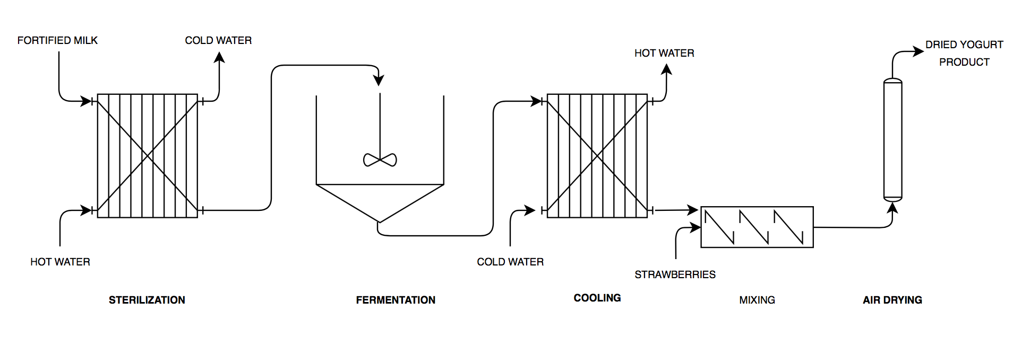

*Figure 1: Process flow diagram of the production of yogurt*

Add separation instead of mixing in strawberries for greek yogurt

### Management Plan

#### Tasks and Deadlines



*Figure 2: Task and deadline list*



*Figure 3: Gantt chart of project workload*

#### Group Member Responsibilities

*Table 3: Group Roles*

|  |  |  |  |  |
| --- | --- | --- | --- | --- |
| **Team Member** | **Kathryn Atherton** | **Rohit Chatterjee** | **Barbara McAnulty** | **Hannah O'Neill** |
| **Literature Review Role** | **Phase Leader** / Writer | Fermentation Literature Review | Microorganisms Literature Review | Dehydrating Literature Review |
| **Mentor Search Role** | Liaison | Mentor Research | Meeting Planner | Meeting Planner |
| **Recipe Mass Balance Role** | Concept Review/ Supplies List | Mass Balance Code | Process Review | **Phase Leader** |
| **Recipe Energy Balance Role** | Process Review | **Phase Leader** | Concept Review/ Heat transfer medium | Energy Balance Coder |
| **Prototype Creation Role** | Assay Design | Improvements | **Phase Leader** | Experimental Design |
| **Results Communication Role** | Data Analysis | Results Summary | Literature Review | Project Documentation |

### Resources

Adolfsson, Oskar. "Yogurt and Gut Function." *The American Journal of Clinical Nutrition*, vol. 80, no. 2, 1 Aug. 2004, pp. 245-56, doi:10.1093/ajcn/80.2.245. Accessed 17 Sept. 2018.

Allgeyer, L C, et al. "Sensory and microbiological quality of yogurt drinks with prebiotics and probiotics." *Journal of Dairy Science*, vol. 93, no. 10, Oct. 2010, pp. 4471-79, doi:10.3168/jds.2009-2582. Accessed 15 Sept. 2018.

Cajigas, Stanley. Instant Yogurt Composition and Process. US005145697A, US Patent and Trademark Office, 8 September 1992.

Chandan, R., White, C., Kilara, A., Hui, Y. (2006). *Manufacturing Yogurt and Fermented Milks*. Ames, IA: Blackwell Publishing.

Chuayana Jr, Eduardo L., et al. "Antimicrobial activity of probiotics from milk products." *Phil J. Microbiol. Infect. Dis*32.2 (2003): 71-74.

“Food Facts: How Much Water Does It Take to Produce?” *Water Education Foundation*. N.d. Accessed 16 Sept. 2018.

Laureati, M et al. "Sustainability and organic production: How information influences consumer’s expectation and preference for yogurt." *Food Quality and Preference*, vol. 30, no. 1, Oct. 2013, pp. 1-8. Accessed 17 Sept. 2018.

Kim, Suk S., and Santi R. Bhowmik. "Survival of Lactic Acid Bacteria during Spray Drying of Plain Yogurt." *Journal of Food Science*, vol. 55, no. 4, July 1990, pp. 1008-10.

Mintel Group Ltd. “Yogurt and Yogurt Drinks, US, August 2017” *Mintel Academic,* August 2017. Accessed 14 Sept. 2018.

Newkey-Burden, C. “Dairy is scary. The public are waking up to the darkest part of farming.” *The Guardian*. March 30, 2017. Accessed 16 Sept. 2018.

Scrimshaw, N S., and E B. Murray. "The acceptability of milk and milk products in populations with a high prevalence of lactose intolerance." *The American Journal of Clinical Nutrition*, vol. 48, no. 4, 1 Oct. 1988, pp. 1142-59. Accessed 17 Sept. 2018.

Serra, M, et al. "Acid coagulation properties and suitability for yogurt production of cows’ milk treated by high-pressure homogenisation." *International Dairy Journal*, vol. 17, no. 7, July 2007, pp. 782-90. Accessed 14 Sept. 2018.

“Sustainable Agriculture: Dairy.” *World Wildlife Foundation*. November 17, 2015. Accessed 16 Sept. 2018.

“United States Yogurt Market and Yogurt Innovation Report 2018 - Market to Reach $9.8 Billion by 2022”. *Research and Markets*. June 13, 2018. Accessed 17 Sept. 2018

Varan, Cyrus O. Method and Apparatus for Dehydration of Yogurt during Transportation and Storage. US005356638A, US Patent and Trademark Office, 18 October 1994.

“Yogurt”. *The Nutrition Source*. May 30, 2018. Accessed 17 Sept. 2018

Zhu, Yunwo, et al. "Competition between yogurt probiotics and periodontal pathogens in vitro." *Acta Odontologica Scandinavica*, vol. 68, no. 5, May 2010, pp. 261-68, doi:10.3109/00016357.2010.492235. Accessed 15 Sept. 2018.